**3D Games Design**

**Assignment 2:**

**Code and Report – OpenGL Game**

**Brandon Batson s5312506**

**Overview**

The program is intended to be a side-scrolling game where the player must jump over an obstacle using OpenGL as a renderer and SDL to create a window for OpenGL to render to. The program will allow for user input in order to zoom the camera in and out, as well as make the character jump over obstacles.

**Specification**

At a minimum the program will be able to render multiple objects, those being the player character, something to jump over such as a box or a spike and a floor[1] for the player to stand on. The program will demonstrate a simplistic way of going about creating a side-scrolling game with basic mechanics and graphics.

The program would also demonstrate simple input in order to control the camera/player character. Such as jumping (player), zooming (camera) and moving (player).

**Program Design**

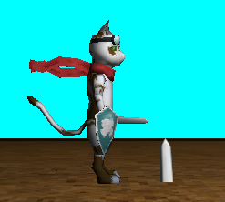For the character, I used the provided “curuthers” cat model as the player model.

The object the player must dodge is a re-used curuthers cat, rotated to face upwards and scaled up. Using the sword from the model looked good as a sort of ‘Spike’ to act as an obstacle for the player to try and avoid. The rest of the model is masked by the ground in order to keep the immersion.

I used lerping between two points in order to emulate jumping, if the player holds the spacebar for a certain amount of time, the game will automatically make them drop back down, as well as the player also being able to only press the spacebar for a short time in order to allow for controlled jumps.

I also allowed the use of the W and S keys in order to zoom the camera in and out, in case the user wanted to seem more of what was going on.

Code has been wrapped into separate files e.g. gameobject.cpp and .h files as well as shader.cpp and .h files in order to increase performance and reduce clutter in the main.cpp file.

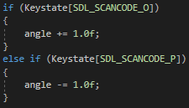The program utilizes both the O and P keys in order to view the model from different angles by orbiting the camera around in either a clockwise or anti-clockwise direction.

**Analysis of Program**

While the program does have some sort of playability and proof of concept, the game could have done with having a full game loop and some sort of objective/score.

I could have also spent time looking at and experimenting with different lighting techniques such as specular and diffuse lighting in order to make the demo look better.

**References**

[1] Floor Object: https://www.turbosquid.com/3d-models/3d-welcome-mat-1418496